Incoming Mutual Fund Gift

This form is to be completed by a U.S. Bank representative. Please provide as much information as possible. If you are unable to provide certain information, indicate that it is unknown. By submitting this document and SPQR request, you are confirming you have permission from the client to receive this mutual fund gift.

Donor Account Information

Delivering Firm Name:

Donor Name/Account Name:

CUSIP/Ticker:

Expected Share Amount: 40

Receiving U.S. Bank Account Information

Receiving Firm Name: U.S. Bank N.A

U.S. Bank Trust Account Number: 6731033100

U.S. Bank Trust Account Name: MEALS-ON-WHEELS SD ENDOWMENT FD CU 10.31.2024

Select One: Mutual Fund Dividend and Capital Gains Reinvestment

C/C - Cash Dividends / Cash Capital Gains

R/R - Rein Dividends / Rein Capital Gains

C/R - Cash Dividends / Rein Capital Gains

\*C/C will be chosen if no other option is selected

Provide Mutual Fund Delivery Instructions to:

Name:

Contact Information:

Instructions to Submit a Gift Request in SPQR

Initiate an SPQR Receipt – Incoming Account Transfer Authorization. Fill in as much information as you have available. Incoming Account Transfer Authorization requests are the only request type available to receive a mutual fund gift.

If you do not know the contra party, select Other and fill in “Unknown.”

If you do not know the Contra Party Account Name, fill in “Unknown.”

If you do not know the Contra Party Account Number, fill in “Unknown.”

If you do not know the Account Type, select Other.

If you do not know the SSN/TIN, use “999999999.”

Please fill in this portion to match the below:

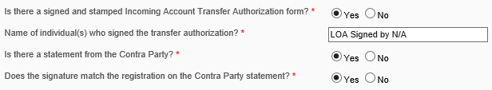

Attach this form to the request as the “Statement from Contra Firm” and “Incoming Account Transfer Authorization Form.”